详细设计说明书

监控系统事业部X-MIS信息管理系统
2010-06-10

北京中水科水电科技开发有限公司

版本控制
版本号 | 注释 | 日期 | 作者

目录
版本控制 2
C00 约束 13
C001 业务约束 13
C003 技术约束 13
A00 架构设计 13
A001 层次结构 13
A002 功能模块 13
F00 功能实现 13
第一阶段

功能实现：用户登录，任务统计，合同管理（全部），项目管理（部分），人员管理（部分），及权限控制（部分）

- 用户登录
- 任务统计（0.5周）
  - 新的任务
  - 我的任务
  - 历史任务
- 合同管理（5周）
  - 合同信息录入（主合同信息，收付款条件，功能模块信息，设备清单信息）
  - 票据收发登记
  - 合同款收付登记
  - 合同执行状态查询
- 项目管理与合同管理相关部分（3周）
  - 项目启动
  - 任务分配
  - 项目状态查询
- 人员管理与合同管理，及项目管理相关部分（1周）
  - 组织架构数据灌入
  - 组织架构数据查询（与合同，项目相关信息）
- 权限控制（0.5周）
  - 登录权限
  - 工作流角色控制

编程：10周
单元测试：1周
集成测试：1周

预计开发周期：12周

开发环境
开发平台：Windows XP
开发工具：Eclipse3.2，JDK1.5
开发语言：Java，JSP，JavaScript，CSS，XML
开发框架：Struts1.2+Spring+AJAX+FireWorkFlow
Web Server: Tomcat 5.5.28
数据库：SQL Server 2000

软件架构

Framework
- Struts + Spring + JDBC
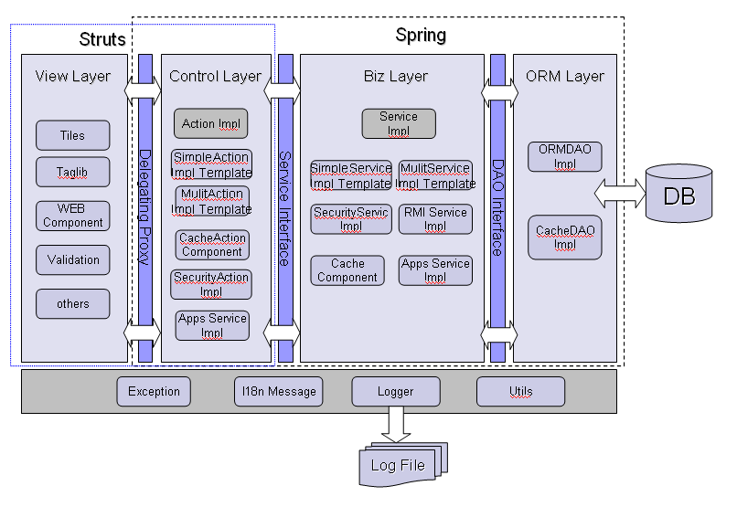
- Web layer: JSP + Spring,
- Business layer: Spring
- Data access: Spring
- Data Encapsulation: Value Object Class

Layers
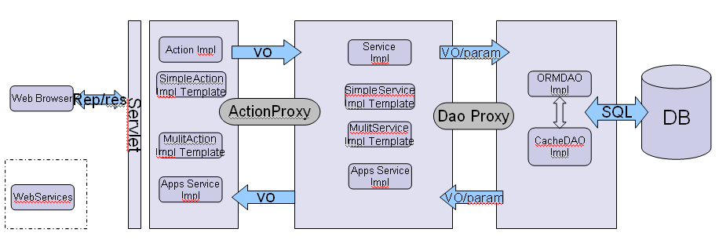

Layer | Description
View | Jsp, java script, CSS
Action | ***.do
Biz | Spring Interceptor
DAO | JDBCTemplate & TransactionTemplate

Modules
Layer | Module | Todo | Description
View(web) | Link | User click link to access a controller, controller return the view. | The returned view is jsp page
View(web) | Form | Submit a Form;
View(web) |  | Form.onSubmit() | Form validation in js.
View(web) | JavaScript and CSS | Manager the layout and style of pages | Do form validation in javascript.
Action | Controller | xxxAction.xxxx(request, response) | Page flow control,
Biz | Biz logic | to do biz logic | Biz logic control  call dao to do data process
DB access | DAO | .getXxxx() | Dao interface
DB access | Jdbc implement | .getXxx(ds) | Run SQL/proc, return data object.
DB access | SQL, proc

文件结构
JAVA Package:
com.bitc.jk.xmis
com.bitc.jk.xmis.web.action.*
com.bitc.jk.xmis.web.form.*
com.bitc.jk.xmis.util.*
com.bitc.jk.xmis.model.*
com.bitc.jk.xmis.service.*
com.bitc.jk.xmis.service.impl.*
com.bitc.jk.xmis.dao.*
com.bitc.jk.xmis.dao.impl.*

WEB Files:
web-root/*
web-root/portal/*
web-root/task/*
web-root/project/*
web-root/contract/*
web-root/employee/*
web-root/materials/*
web-root/meeting/*
web-root/crm/*
web-root/defect/*
web-root/product/*
web-root/bitc-wiki/*
web-root/suggestion/*

web-root/resources/css/*
web-root/resources/images/*
web-root/resources/js/*
web-root/resources/xml/*

WebApplication Name: xMIS

功能实现

用户登录
File list
JSP: web-root/login.jsp
Action: com.bitc.jk.xmis.action.LoginAction.java
Value object: com.bitc.jk.xmis.model.UserObj.java
Interface: com.bitc.jk.xmis.service.LoginService.java
com.bitc.jk.xmis.dao.UserDAO.java
Implement: com.bitc.jk.xmis.service.LoginServiceImpl.java
com.bitc.jk.xmis.dao.UserDAOImpl.java

Interface list:
- userValidete(String loginName, String password) return userID;
- getUserRight(int userID) return userRightList

新的任务
File list
JSP: web-root/task/newTaskList.jsp
Action: com.bitc.jk.xmis.action.TaskAction.java
Value object: com.bitc.jk.xmis.model.TaskObj.java
Interface: com.bitc.jk.xmis.service.TaskService.java
com.bitc.jk.xmis.dao.TaskDAO.java
Implement: com.bitc.jk.xmis.service.TaskServiceImpl.java
com.bitc.jk.xmis.dao.TaskDAOImpl.java

Interface list:
- getTaskList(int userID, int taskType) return taskList
- getTaskInfoByID(int userID, int taskID) return taskObj
- getTaskListByDate(int userID, Date date, int taskType) return taskList
- getTaskListByGroup(int userID, int groupType, int taskType) return taskList
- doReceive(int userID, int taskID)
- doReject(int userID, int taskID)

Parameter
int taskType: 1- New (default)
int groupType: base on TaskGroupType Table

我的任务
File list
JSP: web-root/task/myTaskList.jsp
Action: com.bitc.jk.xmis.action.TaskAction.java
Value object: com.bitc.jk.xmis.model.TaskObj.java
Interface: com.bitc.jk.xmis.service.TaskService.java
com.bitc.jk.xmis.dao.TaskDAO.java
Implement: com.bitc.jk.xmis.service.TaskServiceImpl.java
com.bitc.jk.xmis.dao.TaskDAOImpl.java

Interface list:
- getTaskList(int userID, int taskType) return taskObjList
- getTaskInfoByID(int userID, int taskID) return taskObj
- getTaskListByDate(int userID, Date date, int taskType) return taskList
- getTaskListByGroup(int userID, int groupType, int taskType) return taskList
- doSave (int userID, int taskID)
- doForward(int userID, int taskID)

Parameter
int taskType: 2- Mine (default)
int groupType: based on TaskGroupType Table

历史任务
File list
JSP: web-root/task/historyTaskList.jsp
Action: com.bitc.jk.xmis.action.TaskAction.java
Value object: com.bitc.jk.xmis.model.TaskObj.java
Interface: com.bitc.jk.xmis.service.TaskService.java
com.bitc.jk.xmis.dao.TaskDAO.java
Implement: com.bitc.jk.xmis.service.TaskServiceImpl.java
com.bitc.jk.xmis.dao.TaskDAOImpl.java

Interface list:
- getTaskList(int userID, int taskType) return taskList
- getTaskInfoByID(int userID, int taskID) return taskObj
- getTaskListByDate(int userID, Date date, int taskType) return taskList
- getTaskListByGroup(int userID, int groupType, int taskType) return taskList

Parameter
int taskType: 3- Unfinished (Historical Task forwarded to others but without finished) default
4- Finished (Historical Task with finished)
0- All (1+2+3+4)

项目进度提示
File list
JSP: web-root/portal/projectStatusList.jsp
Action: com.bitc.jk.xmis.action.ProjectAction.java
Value object: com.bitc.jk.xmis.model.ProjectObj.java
Interface: com.bitc.jk.xmis.service.ProjectService.java
com.bitc.jk.xmis.dao.ProjectDAO.java
Implement: com.bitc.jk.xmis.service.ProjectServiceImpl.java
com.bitc.jk.xmis.dao.ProjectDAOImpl.java

Interface list:
- getProjectList(int userID, Boolean isFinished) return projectList
- getProjectInfoByID(int projectID) return projectObj
- getProjectWorkProductListByID(int projectID) return workProductList

Parameter
Boolean isFinished: false- Unfinished
true- Finished (all of contracts with project finished done)
Null - All (False+True)

合同状态提示
File list
JSP: web-root/portal/contractStatusList.jsp
Action: com.bitc.jk.xmis.action.ContractAction.java
Value object: com.bitc.jk.xmis.model.ContractObj.java
Interface: com.bitc.jk.xmis.service.ContractService.java
com.bitc.jk.xmis.dao.ContractDAO.java
Implement: com.bitc.jk.xmis.service.ContractServiceImpl.java
com.bitc.jk.xmis.dao.ContractDAOImpl.java

Interface list:
- getContractList(int userID, Boolean isFinished) return contractList
- getContractInfoByID(int contractID) return contractObj

收付款信息提示
File list
JSP: web-root/portal/paymentStatusList.jsp
Action: com.bitc.jk.xmis.action.ContractAction.java
Value object: com.bitc.jk.xmis.model.PaymentObj.java
Interface: com.bitc.jk.xmis.service.ContractService.java
com.bitc.jk.xmis.dao.ContractDAO.java
Implement: com.bitc.jk.xmis.service.ContractServiceImpl.java
com.bitc.jk.xmis.dao.ContractDAOImpl.java

Interface list:
- getPaymentList(int userID) return paymentList

主合同信息录入
File list
JSP: web-root/ contract/ contract.jsp
Action: com.bitc.jk.xmis.action.ContractAction.java
Value object: com.bitc.jk.xmis.model.ContractObj.java
Interface: com.bitc.jk.xmis.service.ContractService.java
com.bitc.jk.xmis.dao.ContractDAO.java
Implement: com.bitc.jk.xmis.service.ContractServiceImpl.java
com.bitc.jk.xmis.dao.ContractDAOImpl.java

Interface list:
- getGeneralContractByID(int contractID) return contractObj
- doSaveGeneralContract (contractObj)
- doSaveCRMInfo()

收付款条件录入
File list
JSP: web-root/ contract/ paymentCondition.jsp
Action: com.bitc.jk.xmis.action.ContractAction.java
Value object: com.bitc.jk.xmis.model.ContractObj.java
Interface: com.bitc.jk.xmis.service.ContractService.java
com.bitc.jk.xmis.dao.ContractDAO.java
Implement: com.bitc.jk.xmis.service.ContractServiceImpl.java
com.bitc.jk.xmis.dao.ContractDAOImpl.java

Interface list:
- getPaymentConditionListByID(int contractID) return paymentConditionList
- doSavePaymentCondition (int contractID, paymentConditionObjList)
- doUpdatePaymentCondition(int paymentConditionID, paymentConditionObj)
- doDelPaymentCondition(int paymentConditionID)

功能模块信息录入
File list
JSP: web-root/ contract/ functionModule.jsp
Action: com.bitc.jk.xmis.action. ContractAction.java
Value object: com.bitc.jk.xmis.model.FunctionModuleObj.java
Interface: com.bitc.jk.xmis.service.ProjectService.java
com.bitc.jk.xmis.dao.ProjectDAO.java
Implement: com.bitc.jk.xmis.service.ProjectServiceImpl.java
com.bitc.jk.xmis.dao.ProjectDAOImpl.java

Interface list:
- getFunctionModuleListByID(int projectID) return functionModuleList
- doSaveFunctionModule (functionModuleList)
- doUpdateFunctionModule(int functionModuleID, functionModuleObj)
- doDelFunctionModule(int projectID, int functionModuleID)

设备清单信息录入
File list
JSP: web-root/ contract/ deviceList.jsp
Action: com.bitc.jk.xmis.action. ContractAction.java
Value object: com.bitc.jk.xmis.model.DeviceObj.java
Interface: com.bitc.jk.xmis.service. ProjectService.java
com.bitc.jk.xmis.dao. ProjectDAO.java
Implement: com.bitc.jk.xmis.service. ProjectServiceImpl.java
com.bitc.jk.xmis.dao. ProjectDAOImpl.java

Interface list:
- getDeviceListByID(int projectID) return deviceList
- doSaveDeviceList (deviceList)
- doUpdateDeviceList(deviceObj)
- doDelDevice(int projectID, int deviceID)

票据收发登记
File list
JSP: web-root/ contract/ invoice.jsp
Action: com.bitc.jk.xmis.action.ContractAction.java
Value object: com.bitc.jk.xmis.model.InvoiceObj.java
Interface: com.bitc.jk.xmis.service.ContractService.java
com.bitc.jk.xmis.dao.ContractDAO.java
Implement: com.bitc.jk.xmis.service.ContractServiceImpl.java
com.bitc.jk.xmis.dao.ContractDAOImpl.java

Interface list:
- getInvoiceListByID(int contractID) return deviceList
- doSaveInvoice (invoiceObj)
- doUpdateInvoice(invoiceObj)
- doDeleteInvoice(int contractID, int invoiceID)

合同款收付登记
File list
JSP: web-root/ contract/ payment.jsp
Action: com.bitc.jk.xmis.action.ContractAction.java
Value object: com.bitc.jk.xmis.model.PaymentObj.java
Interface: com.bitc.jk.xmis.service.ContractService.java
com.bitc.jk.xmis.dao.ContractDAO.java
Implement: com.bitc.jk.xmis.service.ContractServiceImpl.java
com.bitc.jk.xmis.dao.ContractDAOImpl.java

Interface list:
- getPaymentListByID(int contractID) return paymentList
- doSavePaymentInfo (int contractID, paymentObj)
- doUpdatePaymentInfo(int paymentID, paymentObj)
- doDelPaymentInfo(int contractID, int paymentID)

合同执行状态查询
File list
JSP: web-root/ contract/ contractReport.jsp
Action: com.bitc.jk.xmis.action.ContractAction.java
Interface: com.bitc.jk.xmis.service.ContractService.java
com.bitc.jk.xmis.dao.ContractDAO.java
Implement: com.bitc.jk.xmis.service.ContractServiceImpl.java
com.bitc.jk.xmis.dao.ContractDAOImpl.java

Interface list:
- getContractReport (int userID, Boolean isFinished) return contractReport

项目启动
File list
JSP: web-root/ project/ projectStartup.jsp
Action: com.bitc.jk.xmis.action.ProjectAction.java
Interface: com.bitc.jk.xmis.service.ProjectService.java
com.bitc.jk.xmis.dao.ProjectDAO.java
Implement: com.bitc.jk.xmis.service.ProjectServiceImpl.java
com.bitc.jk.xmis.dao.ProjectDAOImpl.java

Interface list:
- doSaveProjectInfo(projectObj)
- doUpdateProject(projectObj)
- doSaveProjectTaskInfo(projectTaskObj)

任务分配
File list
JSP: web-root/ project/ projectTaskAssign.jsp
Action: com.bitc.jk.xmis.action.ProjectAction.java
Interface: com.bitc.jk.xmis.service.ProjectService.java
com.bitc.jk.xmis.dao.ProjectDAO.java
Implement: com.bitc.jk.xmis.service.ProjectServiceImpl.java
com.bitc.jk.xmis.dao.ProjectDAOImpl.java

Interface list:
- doSaveProjectTask(projectTaskObj)
- doUpdateProjectTask(projectTaskObj)

项目状态查询
File list
JSP: web-root/ project/ projectReport.jsp
Action: com.bitc.jk.xmis.action.ProjectAction.java
Interface: com.bitc.jk.xmis.service.ProjectService.java
com.bitc.jk.xmis.dao.ProjectDAO.java
Implement: com.bitc.jk.xmis.service.ProjectServiceImpl.java
com.bitc.jk.xmis.dao.ProjectDAOImpl.java

Interface list:
- getProjectReport(int userID) return projectObj

组织架构数据灌入
- table.org_公司
- table.org_部门
- table.org_部门归属公司表
- table.sys_性别
- table.hr_人员
- table.hr_人员部门关系表

组织架构数据查询（与合同，项目相关信息）
File list
JSP: web-root/ organization/ departmentTree.jsp
web-root/ organization/employee.jsp
web-root/ organization/department.jsp
web-root/ organization/ company.jsp
web-root/ organization/ deptORMcomp.jsp
web-root/ organization/ empORMdept.jsp
Action: com.bitc.jk.xmis.action.OrganizationAction.java
Interface: com.bitc.jk.xmis.service.OrganizationService.java
com.bitc.jk.xmis.dao.OrganizationDAO.java
Implement: com.bitc.jk.xmis.service.OrganizationServiceImpl.java
com.bitc.jk.xmis.dao.OrganizationDAOImpl.java

Interface list:
- getDepartmentTree(int companyID) return List
- getEmployeeInfo(int userID) return EmployeeObj
- doSaveCompanyInfo(companyObj)
- doSaveDepartmentInfo(deptartmentObj)
- doSaveEmployeeInfo(employeeObj)
- getProjectListByEmp(int employeeID) return List
- getProjectListByDept(int departmentID) return List

操作权限
- Admin
- Director
- Manager
- Employee
- ContractEditor

C00 约束

C001 业务约束

C003 技术约束

A00 架构设计

A001 层次结构

A002 功能模块

F00 功能实现
F01 功能名称
1 Files name
2 Parameters
3 Method name
4 Value Object
5 Exception
6 SQL

